**PROJECT REPORT FOR DJANGO-EPAY**

|  |  |
| --- | --- |
| **PROJECT SUBMITTED BY**: | **TRAINER NAME** |
| 1. KARANAM SRAVYA 2. K.R. MEGHANA 3. HARSHITHA J R 4. REETHU PRIYA. M.S | Venkatasubramanian r |

**INTRODUCTION TO DJANGO**

Django is a high-level python web framework that encourages rapid development and clean pragmatic design. A web framework is set of components that provide a standard way to develop websites fast and easily. Django’s primary goal is to ease the creation of complex database driven websites. Some well-known sites that use Django includes PBS, Instagram, Disqus, Washington Times, Bitbucket and Mozilla.

**INTRODUCTION TO DJANGO E-PAY**

E-PAY is built using Django. There are two accounts, one is the Admin where, can add, delete the products and he can also view the users profile. Another is the User where he can view the existing products, buy them and he can also add those products to his cart.

In home page there are two options in the navbar namely, Register and Login. If the user is new, the user is subjected to register with the required credentials. After registering user can login with his username and password. The way this is done is by creating a Payline Wallet with the payment information provided by the user, storing this wallet ID in a Wallet model, and allowing payments to be done using this wallet. One user can transfer money from his account to another user.

* **UNIT’S FUNCTIONALITY**

User Authentication is provided, user can login with his username and password. If the person is new user, is subjected to register with the credentials. Register page redirects to Login page. Login page redirects into View page, there user can buy the products, add products to his cart and user can also view his current balance . Later user can delete the products from his cart or buy them. User has the option to send the money to another. User can logout which directs to Home page.

* **DEVELOPMENT METHODOLOGIES**

SDLC is a process followed for a software project, within a software organization. It consists of a detailed plan describing how to develop, maintain, replace and alter or enhance specific software. The life cycle defines a methodology for improving the quality of software and the overall development process.

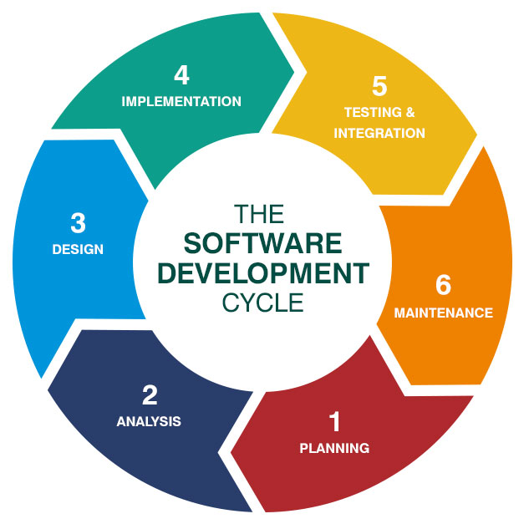

* **Source Code**

The source code is available on GitHub <https://github.com/SreeKaranam/DjangoPAY>

* **Requirements**

dj-database-url==0.5.0

Django==2.2.2

gunicorn==19.9.0

pytz==2019.1

sqlparse==0.3.0

whitenoise==4.1.2

psycopg2==2.8.3

* **Libraries, Tables and Directories**

|  |  |  |
| --- | --- | --- |
| **Libraries** | **Tables** | **Directories** |
| django | Watch | Offline Wallet |
| django.apps | Phone |  |
| django.http | Laptop |  |
| django.urls | Product |  |
| django.contrib |  |  |
| django.core.wsgi |  |  |
| django.shortcuts |  |  |
| django.contrib.auth |  |  |
| django.contrib.auth.forms |  |  |
| django.contrib.auth.models |  |  |

* **ROLES AND RESPONSIBILITES**

The team members have the following roles and responsibilities:

|  |  |  |
| --- | --- | --- |
| **Sl.no** | **NAME** | **ROLES AND RESPONSIBILITIES** |
| **1**. | Karanam Sravya  Reethu Priya. M.S | Secure Authentication of Registered and existing users, Handling with Frontend using Bootstrap and Backend with python code, Writing server-side web application logic and integrating with python application and managing the interchange of data between the servers and users |
| **2.** | K.R. Meghana  Harshitha J R | Dealing with CRUD operations of this E-Pay i.e., editing, deleting of existing ones and creating new ones. A User Interactive Dashboard. Creation of Tables consisting of Watch, Laptop, Phone and Product, Handling with corresponding Database. Initialising to Git repository. |